***A***

***Project Report***

***On***

### “Real Estate CRM”

Submitted

In partial fulfillment of the requirement for the award of degree of

**Bachelor of Technology**

In

Information Technology

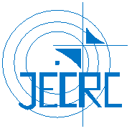

**(Session 2018-2019)**

**Submitted to: Submitted by:**

**Dr. Sunil Kumar Jangir Sanchit Bhargava**

**HOD, IT [15EJCIT070]**

**Mr. Naveen Kumar Kedia Tanushri Goyal**

**Project Coordinator, IT [15EJCIT085]**

**Mr. Piyush Gautam Rahul Soni**

**Project Guide, IT [15EJCIT060]**

**Manisha Shekhawat**

**[15EJCIT301]**

**Department of Information Technology**

**Jaipur Engineering College & Research Centre, Jaipur**

**Rajasthan Technical University, Kota**

**May 2019**